WREN | 2011 Main Street | Bethlehem, NH 03574

FOR IMMEDIATE RELEASE
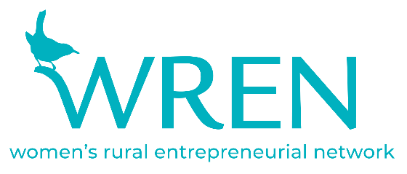
For further info, please contact:
Caitlin Farrar, Microenterprise, Marketing and Membership Manager
caitlinf@wrenworks.org

February 16, 2021
Bethlehem, NH

WREN Receives NH Business Review’s AWE Award

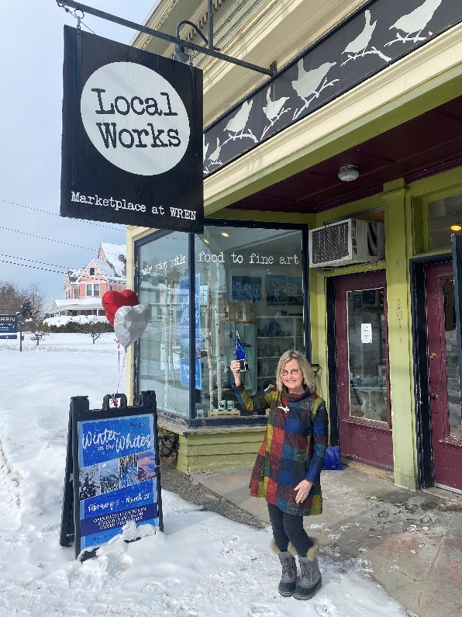
The Women’s Rural Entrepreneurial Network (WREN) is honored to receive NH Business Review’s sixth annual Advocate for Women’s Empowerment Award.

This award, which recognizes individuals or organizations that have made a lasting impact in the empowerment of women and girls in the Granite State, was presented during the virtual ceremony for NH Business Review’s (NHBR) 2021 Outstanding Women in Business Awards on February 11, 2021. A live recording of the virtual ceremony is available for viewing on the “Events & Awards” page on NHBR’s website.

WREN Executive Director Pamela Sullivan accepted the Advocate for Women’s Empowerment (AWE) Award on behalf of the organization. In her remarks, Sullivan reflected back on WREN’s path throughout the past 26 years. In 1994, WREN began as “an ambitious plan” by its 3 co-founders “to start an 8-month training and support program to assist 12 low to moderate income women in achieving their dreams of business ownership. By the spring of 1995, these WREN pioneers were operating their own enterprises.”

Since its humble beginnings, WREN has “assisted nearly 3,000 business owners” through small business-focused classes and workshops, networking and grant opportunities, and marketplace access thanks to the Local Works Marketplace storefront and The Gallery at WREN. As a 501c3 nonprofit, WREN continues to embrace its mission every day by “supporting better lives and livelihoods, enhancing the vitality of Bethlehem’s Main Street and practicing and promoting innovation in rural economic development. WREN inspires possibilities, creates opportunities and builds connections through community.”

The theme of community resonated throughout the AWE award presentation, as well as Sullivan’s speech. “In the North Country we are all about community, and WREN is so grateful to be part of it.” This gratitude is part of everyday life at WREN and shows itself in a variety of ways, including rising to the challenges of the pandemic over the past year.

“In March of 202O COVID hit, and abruptly everything came to a halt. We shut the store and gallery, and all in-person classes were cancelled. Quickly we pivoted, adjusted our programming, and through ZOOM, delivered it online. We made the content more relevant for the new COVID world we were all now living in.” While the pandemic’s ongoing impacts are still unfolding, Sullivan acknowledges that “it was quite clear [that] WREN was needed now more than ever” by small business owners in the region.

Whether that means holding monthly roundtable discussions to notify small business owners of legislative updates thanks to representatives from U.S. Senator Jeanne Shaheen’s office, adapting online classes to better reflect urgent needs brought to light by COVID, or simply providing a space to continue selling when other opportunities are limited, WREN continues to respond to the challenges on the path ahead.

In the closing remarks of her acceptance speech, Sullivan reiterated WREN’s purpose, as well as its power to bring about positive change for small business owners. “We are resilient. We are WREN, and we are North Country Strong.” Thanks to the recognition of NHBR and the AWE Award, WREN will continue to serve its valuable mission under an even brighter spotlight.

Supporters of WREN, as well as small business owners, are encouraged to learn more about the organization and find a way to get involved by visiting wrenworks.org.

About WREN
The Women’s Rural Entrepreneurial Network (WREN) is a nationally recognized nonprofit organization in Bethlehem, NH. WREN provides classes, workshops, community work space, networking and events to support better lives and livelihoods, access to markets, and rural economic development in the North Country.

Local Works Marketplace & the Gallery at WREN Hours:
OPEN: 11am – 5pm, Monday, Tuesday, Thursday, Friday, Saturday, Sunday. CLOSED: Wednesdays.

Local Works Marketplace sells the works of over 90 local artists. To learn more about WREN, visit www.wrenworks.org. 2011 Main St, Bethlehem, NH 03574.

